**MINI PROJECT**

**REPORT FILE**

**TITLE:**

**“WhiteRose”**

**(News Website)**



*Submitted by:*

*TUSHAR BHATT,*

*KARTIK VERMA,*

*KAVYA SINGH NAGI*

*(From CSE DEPARTMENT 3rd YEAR)*

**ABSTRACT**

*"Step into the dynamic world of information with WhiteRose, your gateway to the latest, most compelling news stories curated from the esteemed BBC network. Crafted as a culmination of ingenuity and technological finesse for a minor project, WhiteRose seamlessly integrates HTML, CSS, and Javascript to deliver an immersive user experience. Harnessing the power of the News API, WhiteRose offers real-time updates, ensuring you stay ahead in a fast-paced world. With a sleek interface and intuitive functionalities, including a versatile search bar, WhiteRose empowers users to explore a plethora of topics, from global affairs to niche interests, all at their fingertips. Join us on a journey where every click unveils a new narrative, every scroll ignites curiosity, and every visit promises enlightenment. Welcome to WhiteRose, where information meets innovation."*

**INTRODUCTION**

*Welcome to the digital realm of innovation and information dissemination – where creativity meets technology to redefine the way we engage with news. This introduction serves as your exclusive invitation to explore WhiteRose, a captivating news website meticulously crafted as part of a minor project endeavor. Developed utilizing the dynamic trio of HTML, CSS, and Javascript, WhiteRose stands as a testament to the power of modern web development tools in shaping user experiences.*

*At the heart of WhiteRose lies a commitment to delivering real-time, curated news content sourced directly from the esteemed BBC network. Through seamless integration with the News API, users are empowered with up-to-the-minute updates on global events, trends, and stories that matter. But WhiteRose isn't just about information consumption – it's about empowerment and exploration.*

*With a user-friendly interface designed to captivate and inspire, WhiteRose beckons users to embark on a journey of discovery. Equipped with a robust search bar feature, individuals can effortlessly navigate through a vast sea of news topics, tailored to their interests and preferences. Whether it's delving into breaking news headlines or exploring niche subjects, WhiteRose ensures that every visit is an enriching and immersive experience.*

*Join us as we delve deeper into the intricacies of WhiteRose, where innovation, technology, and the pursuit of knowledge converge to shape the future of news consumption.*

**REQUIREMENT ANALYSIS AND SYSTEM SPECIFICATION**

*In this section, we delve into the meticulous process of analyzing the requirements and specifying the system architecture for the WhiteRose news website.*

*1. Project Objectives*

* *The primary objective of WhiteRose is to create a user-friendly platform for accessing live BBC news updates seamlessly.*
* *Target Audience: General users seeking reliable and up-to-date news information from diverse domains.*

*2. Functional Requirements:*

* *Live BBC News Integration: Real-time retrieval and display of news articles from the BBC network.*
* *Search Functionality: A robust search bar enabling users to find news articles based on specific keywords.*
* *Navigation Menus: Intuitive navigation menus for easy exploration of news categories and sections.*
* *User Authentication: Secure user authentication and account management functionalities.*

*3. Validation and Verification:*

* *Testing Strategy: Comprehensive testing of functionalities to ensure they meet specified requirements.*
* *Acceptance Criteria: Clear criteria for determining whether the implemented system fulfills the project objectives.*
* *User Feedback: Gathering feedback from users to identify areas for improvement and refinement.*

*By meticulously analyzing the requirements and specifying the system architecture, we lay the foundation for the successful development and deployment of the WhiteRose news website, ensuring it meets the needs and expectations of its users.*

**SYSTEM DESIGN**

*1. Overall Architecture:*

* *Frontend: Utilizing HTML, CSS, and Javascript to create a visually appealing and interactive user interface.*
* *Third-party APIs: Integration with the News API to fetch live news updates from the BBC network*

*2. Component Design:*

* *Search Bar: Implementing a search bar component with autocomplete functionality for efficient news article retrieval.*
* *News Article Display: Designing components to display news articles in a visually engaging format, including headlines, summaries, and images.*
* *Navigation Menus: Creating intuitive navigation menuzzfor easy exploration of news categories and sections.*

*3. Scalability and Performance:*

* *Horizontal Scaling: Designing the system to scale horizontally by adding more server instances to handle increased traffic and load.*
* *Caching: Implementing caching mechanisms to store frequently accessed news articles and improve response times.*
* *Asynchronous Processing: Utilizing asynchronous processing techniques to handle concurrent requests efficiently and enhance system performance.*

*4. User Experience Design:*

* *Responsiveness: Designing the website to be responsive across various devices and screen sizes, ensuring a seamless user experience.*
* *Accessibility: Incorporating accessibility features to make the website usable for individuals with disabilities, such as screen readers and keyboard navigation support.*
* *User Feedback: Implementing feedback mechanisms to gather user input and insights for continuous improvement of the user experience.*

**IMPLEMENTATION, TESTING, AND MAINTENANCE**

*1. Implementation:*

* *Frontend Development: Executing the design specifications using HTML, CSS, and Javascript to create an intuitive and visually appealing user interface..*
* *API Integration: Connecting with the News API to fetch live news updates from the BBC network and integrating authentication mechanisms for user management.*
* *Deployment: Deploying the application on a web server or cloud platform, ensuring seamless accessibility to users.*

*2. Testing:*

* *Unit Testing: Conducting unit tests to validate the functionality of individual components, including frontend UI elements, backend APIs, and data processing logic.*
* *Integration Testing: Testing the interaction between different components of the system, including API endpoints, database operations, and external API integration.*
* *End-to-End Testing: Performing end-to-end testing to simulate user interactions and verify the system's behavior and functionality from the user's perspective.*
* *User Acceptance Testing (UAT): Involving stakeholders and real users to validate the system against predefined acceptance criteria and gather feedback for improvements.*

*3. Maintenance:*

* *Bug Fixing: Addressing any identified issues or bugs through timely debugging and troubleshooting to maintain the system's integrity and functionality.*
* *Performance Optimization: Monitoring system performance and identifying areas for optimization, such as database queries, server response times, and frontend rendering, to ensure optimal user experience.*
* *Security Updates: Regularly updating the system to address security vulnerabilities and protect against potential threats, including implementing security patches and best practices.*
* *Feature Enhancements: Continuously improving the website by adding new features, refining existing functionalities, and incorporating user feedback to enhance the overall user experience.*
* *Monitoring and Support: Implementing monitoring tools to track system health, performance metrics, and user interactions, and providing ongoing support to address user inquiries and technical issues.*

**RESULT & DISCUSSION**

*1.Website Snapshot:*

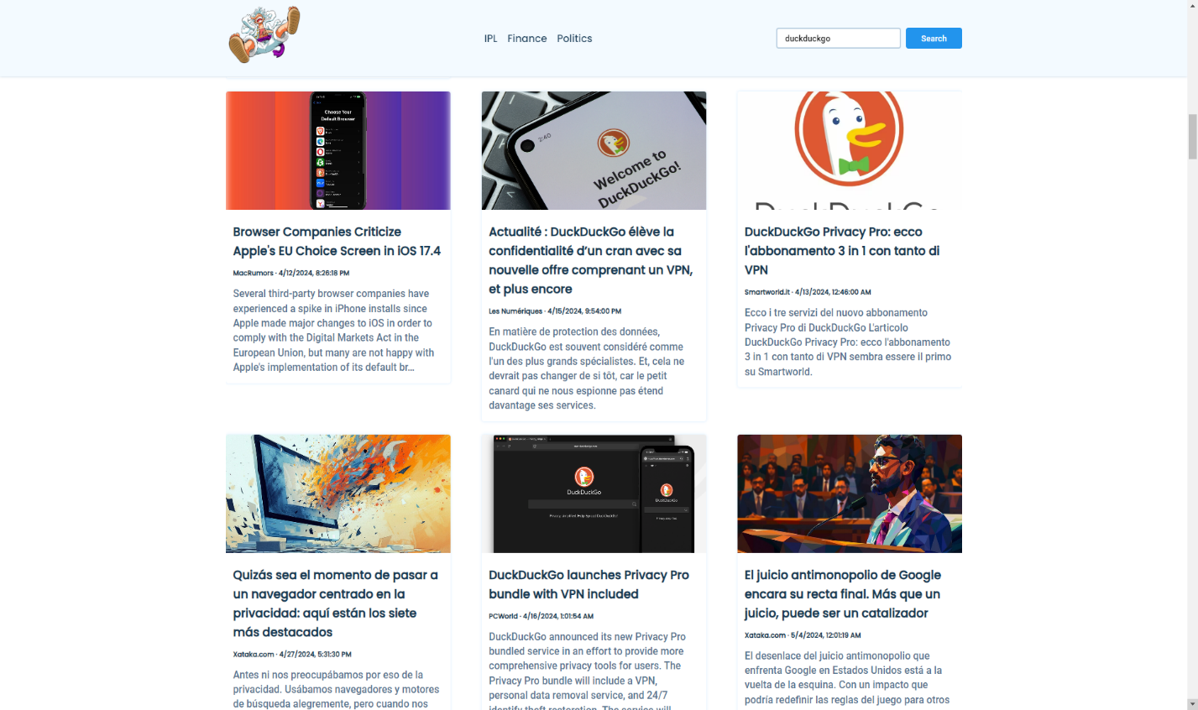

*2. Performance Evaluation:*

* *Loading Speed: Analyzing the website's loading speed using tools like Google PageSpeed Insights or Lighthouse to ensure optimal performance.*
* *Responsiveness: Assessing the website's responsiveness across different devices and screen sizes to ensure a seamless user experience.*
* *Server Response Time: Monitoring server response times to identify bottlenecks and optimize backend performance.*

*3. Discussions:*

* *Strengths and Limitations: Discussing the strengths of the WhiteRose website, such as its real-time news updates, user-friendly interface, and seamless integration with the BBC API, as well as any limitations or areas for improvement.*
* *Future Enhancements: Proposing potential enhancements or features to further enhance the website's functionality, usability, and user engagement.*
* *User Adoption: Reflecting on user adoption rates and feedback to assess the website's effectiveness in meeting user needs and expectations.*
* *Impact on News Consumption: Discussing the potential impact of the WhiteRose website on news consumption habits and information dissemination in the digital age.*

**CONCLUSION &**

**FUTURE SCOPE**

*In conclusion, the development and implementation of the WhiteRose news website mark a significant milestone in providing users with a seamless and immersive platform for accessing live BBC news updates. Through meticulous design, robust implementation, and thorough testing, WhiteRose has emerged as a reliable source of real-time information, offering users a user-friendly interface and intuitive features for navigating through diverse news topics.*

*In conclusion, the WhiteRose news website represents not only a successful implementation of a minor project but also a promising platform for delivering timely and relevant news content to users worldwide. By embracing innovation, user-centric design, and continuous improvement, WhiteRose is poised to become a leading destination for news consumption in the digital age.*

**REFERENCES/BIBLIOGRAPHY**

1. *MDN Web Docs. (n.d.). HTML: Hypertext Markup Language. Retrieved from* [*https://developer.mozilla.org/en-US/docs/Web/HTML*](https://developer.mozilla.org/en-US/docs/Web/HTML)
2. *MDN Web Docs. (n.d.). CSS: Cascading Style Sheets. Retrieved from* [*https://developer.mozilla.org/en-US/docs/Web/CSS*](https://developer.mozilla.org/en-US/docs/Web/CSS)
3. *MDN Web Docs. (n.d.). JavaScript. Retrieved from* [*https://developer.mozilla.org/en-US/docs/Web/JavaScript*](https://developer.mozilla.org/en-US/docs/Web/JavaScript)
4. *News API Documentation. (n.d.). Retrieved from* [*https://newsapi.org/docs*](https://newsapi.org/docs)
5. *BBC News. (n.d.). Retrieved from* [*https://www.bbc.com/news*](https://www.bbc.com/news)
6. *Nielsen Norman Group. (n.d.). Usability 101: Introduction to Usability. Retrieved from* [*https://www.nngroup.com/articles/usability-101-introduction-to-usability/*](https://www.nngroup.com/articles/usability-101-introduction-to-usability/)
7. *W3C. (n.d.). Web Content Accessibility Guidelines (WCAG) Overview. Retrieved from* [*https://www.w3.org/WAI/standards-guidelines/wcag/*](https://www.w3.org/WAI/standards-guidelines/wcag/)
8. *Google PageSpeed Insights. (n.d.). Retrieved from* [*https://developers.google.com/speed/pagespeed/insights/*](https://developers.google.com/speed/pagespeed/insights/)